Tribhuwan University

Central Campus, IOE, Pulchowk



Project primo

Proposal on project of Object Oriented Programming

Submitted by:

Arjun Dahal (071/BEX/405)

Biplab Gautam (071/BEX/411)

Bishal Khanal (071/BEX/412)

Date: 2072/10/29

Submitted to:

Department of Electronics and Computer Engineering

**Acknowledgement**

The project in Object Oriented Programming in C++ is significant not only because it is specified in the curriculum and it weighs some marks but also it provides a platform for students to be familiar with the programming ideas and projects in object oriented approach. We are glad that the university has ushered us to this way of learning. Obviously, the syntax learning is one part but unless you do a project in a language, you cannot understand the core of the language. So, we are very grateful to the Department of Electronics and Computer Engineering, Central Campus, IOE for providing us the opportunity. We are sure that we will strive to make our project a success.

We must acknowledge the peculiar numbers in the number system, ‘Prime numbers’ which are the source of inspiration for us. We must mention that the very popular ‘2048 game’ made us believe that we can do this project. We are very thankful to our teacher Mr. Basanta Joshi and all our friends who have always supported and helped us.

Arjun Dahal (071/BEX/405)

Biplab Gautam (071/BEX/411)

Bishal Khanal (071/BEX/410)

**Table of Contents:**

**S.N. Topic Page no’**

1. Introduction 3

2. Objectives 3

3. Existing System 3

4. Proposed System 3

4.1 Description 3

4.2 System Block Diagram 9

5. Methodology 9

6. Project Scope 9

7. Project Schedule 10

**1. Introduction:**

‘Primo’ is a number’s game. The name *Primo* is extracted from Spanish word *Numero Primo* which means prime numbers. Each level is assigned a particular prime number and the main objective of the player is to get that particular prime number by following the rules of the game. This game is little bit unconventional in the sense that the levels don’t start from 1, 2, 3, … instead, the level starts from first two-digit prime number 11 and goes on as 11, 13, 17, 19, ….

**2. Objectives:**

The game is primarily for fun and specially to someone who is enthusiastic about mathematics and numbers (more specific prime numbers). The concept of prime number is little bit tough to comprehend. The user will get to know about the prime numbers and may be its pattern of occurrence. This is a strategic and calculative game, so it will obviously sharpen the user’s analytical and mental skills.

**3. Existing System:**

Actually, this game is one of the first of its kind. But we must admit that there is a game called ‘2048’ which is also a number’s game where the user plays to make numbers which are integral powers of 2 and scoring is done accordingly. The game is a source of inspiration for us but we have not encountered such games on prime numbers.

**4. Proposed System:**

**4.1 Description:**

‘Primo’ consists of playing board as shown in figure aside (design done using Adobe Illustrator).

Aim of each level is to make the prime number corresponding to that level (as indicated in the top of the board in the figure).

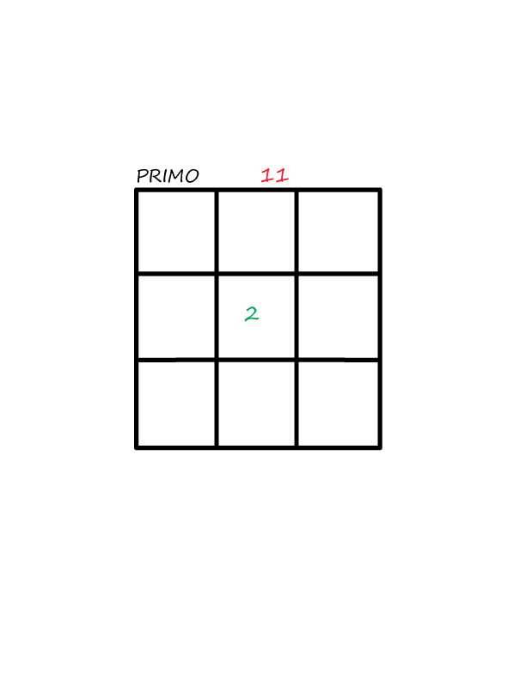

While playing the game the numbers pop out for each movement done by using the cursor keys.

The basic numbers (1,2,3,4,5) can pop out randomly from any box, empty in the board after every move. *Diagram 1*

The basic rule of the game is when a cursor key is pressed the numbers try to add along that direction in a particular row or column, if they encounter another number. But addition needs certain conditions to be fulfilled. The conditions are:

1. Composite numbers (numbers except prime) can add among themselves.
2. Friendly numbers (Term for the game) 1 and 2 add to any number prime or composite.
3. Prime numbers only add to make another prime number.

These statements will be more clear on further illustration mentioned just below:

The program starts as in diagram 1 with a single number. Suppose, cursor key ‘down’ is pressed.

The number 2 goes down and a new number 3 pops out.

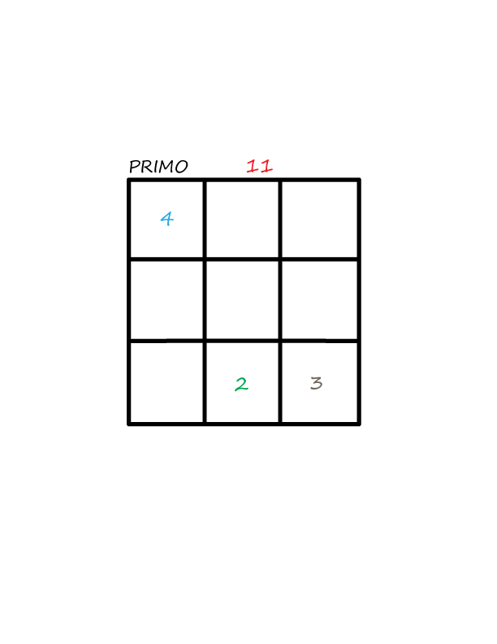

*Diagram 2*

Again, cursor key ‘down’ is pressed and the number 3 comes down and a new number 4 pops out as in the diagram 3.

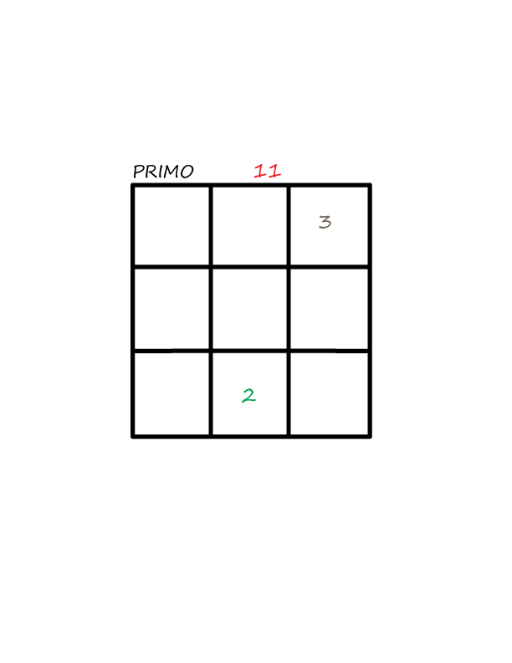

*Diagram 3*

When cursor key ‘left’ is pressed the numbers 2 and 3 since they are addable, are added and number 5 appears in the bottom left box, and a new number 2 pops out as in the diagram 4.

*Diagram – 4*

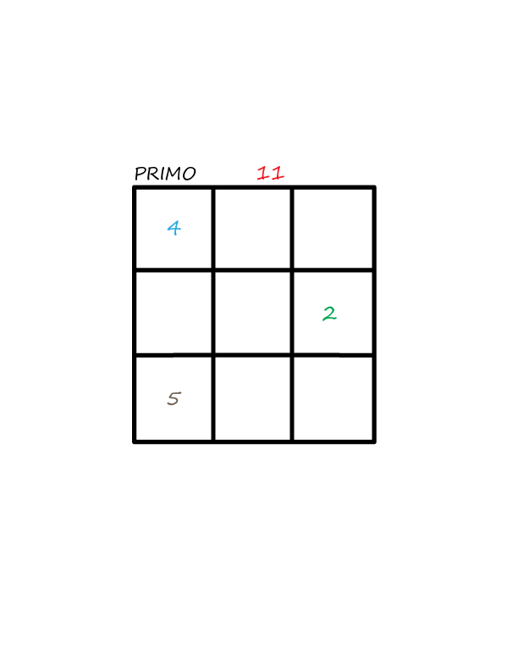

If the ‘down’ cursor key is pressed the number 2 comes to the bottom of its column and the number 4 and 5 encounter each other. But since, 5 is a prime number and addition of 5 and 4 does not result a prime they cannot be added. So, the number 4 just sits in the box just above 5 as in diagram 5 and also a new number 1 pops out.

*Diagram – 5*

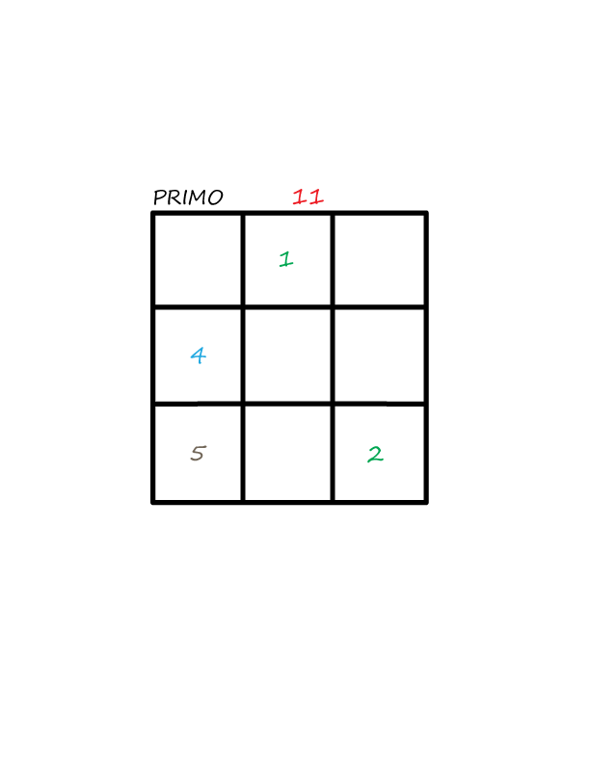

On pressing the ‘left’ cursor key the numbers 5 and 2 add each other as they are addable. Though 5 is a prime addition of 5 with 2 results a prime 7. Also a new number pops out as shown in diagram-6.

*Diagram – 6*

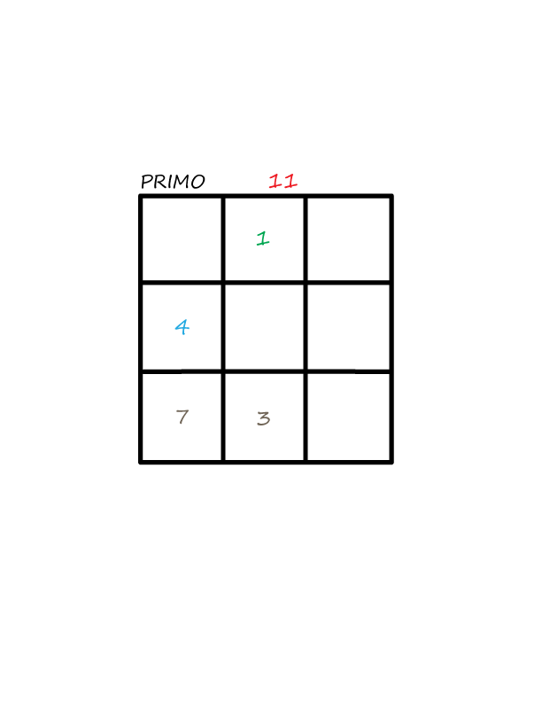

Now, if ‘down’ cursor key is pressed, the numbers 7 and 4 add and make prime number 11. Also, numbers 1 and 3 also add to make number 4 as in diagram 7.

*Diagram - 7*

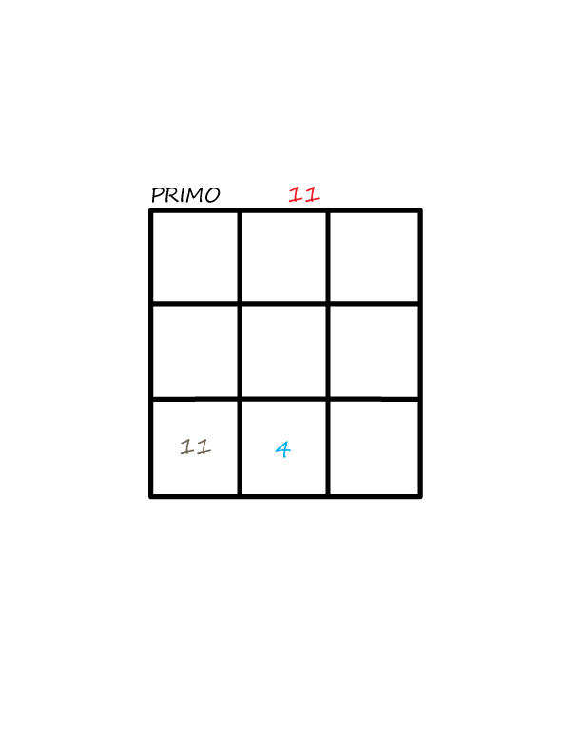

Since the objective of the level, to make a prime number 11, is completed the level is accomplished and a dialog box for new level 13 appears as shown in diagram 8.*Diagram – 8*

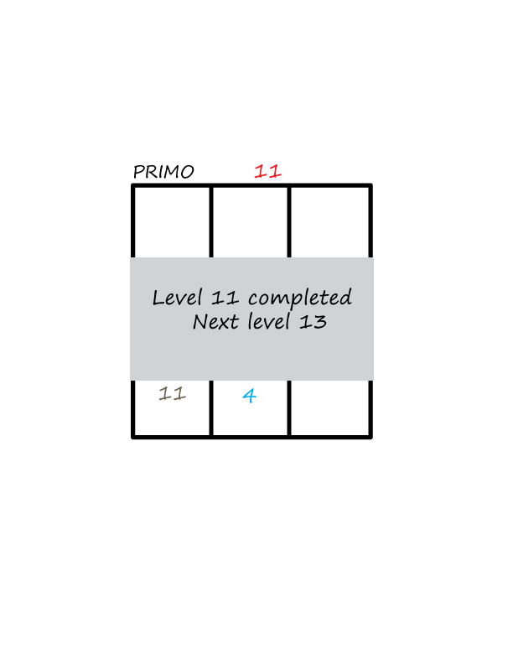

Conditions for failing a level:

1. If the numbers in the box cannot further move and cannot be added due to unaddable conditions.
2. If any number formed by consequent operations is greater than the value of required prime.

**4.2 System Block Diagram**

**5. Methodology:**

The program will be made using Object Oriented Concept in C++ programming language. The concept of Objects and Classes, Inheritance, Polymorphism, etc. which are major features of object oriented programming shall be used. For graphics, Simple DirectMedia Layer shall be used. It is a cross-platform development library designed to provide low level access to audio, keyboard, mouse and graphics hardware.

**6. Project Scope:**

The game ‘Primo’ can be extended and be made as an app for Android or iOS, which is common and important trend in today’s software market. It’s a mathematical game, so obviously it will attract math enthusiasts. It is a strategic game and it provides information on prime numbers so we hope it will contribute in its own way in the field of Mathematics and Gaming.

**7. Project Schedule:**

The project ‘Primo’ is scheduled to be completed around the last weeks of Falgun 2072. It will be submitted to the Department of Electronics and Computer Engineering, Central Campus, IOE on date as specified by the department.